**Day 9 Assignment**

1. Create AFTER UPDATE trigger to track product price changes

· Create product_price_audit table with below columns:

audit_id SERIAL PRIMARY KEY,

product_id INT,

product_name VARCHAR(40),

old_price DECIMAL(10,2),

new_price DECIMAL(10,2),

change_date TIMESTAMP DEFAULT CURRENT_TIMESTAMP,

user_name VARCHAR(50) DEFAULT CURRENT_USER

· Create a trigger function with the below logic:

INSERT INTO product_price_audit (

product_id,

product_name,

old_price,

new_price

)

VALUES (

OLD.product_id,

OLD.product_name,

OLD.unit_price,

NEW.unit_price

);

**Answer**

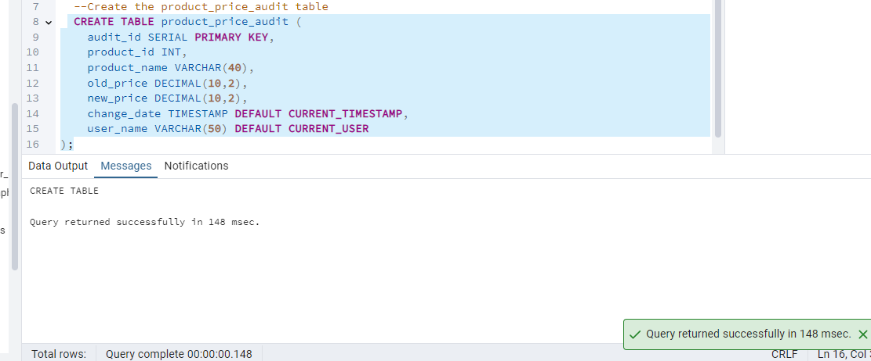

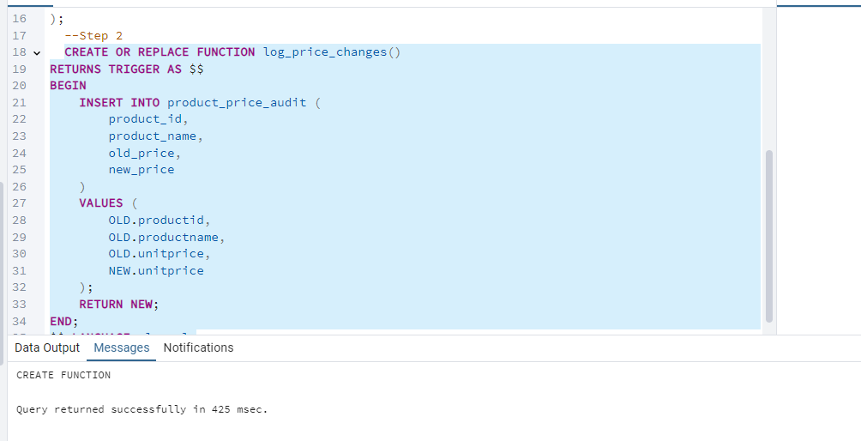

**Step 3**

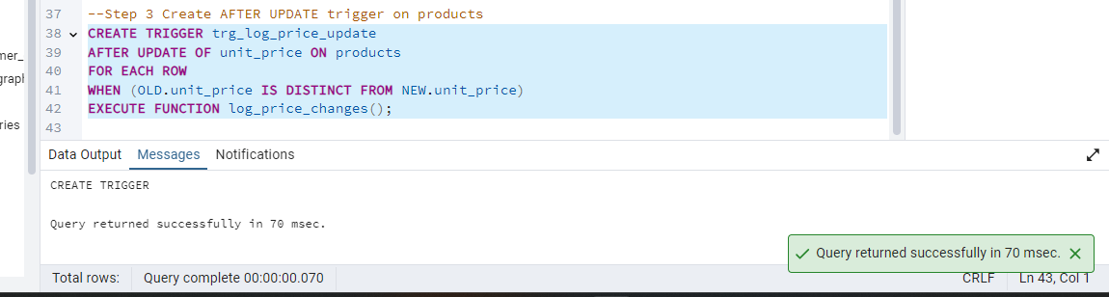

**Test the Trigger**

SELECT product_id, product_name, unit_price FROM products;

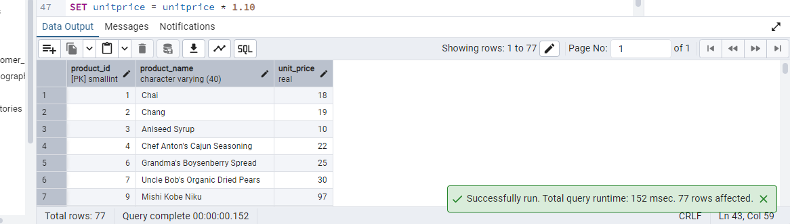

SELECT product_id, product_name, unit_price FROM products LIMIT 5;

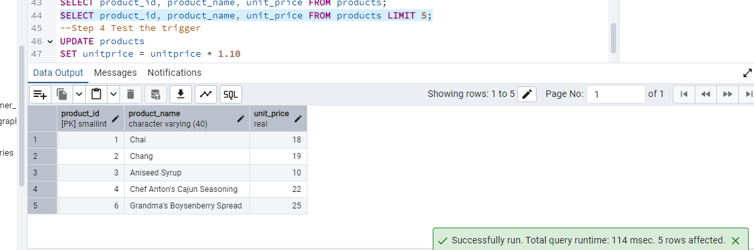

**2.**

